Adobe Captivate Prime
Learning Management System (LMS) QRG for New Hires

How to Sign-In to the Learning Management System (LMS):
- Open a browser (Preferred: Edge or Chrome. Modzilla is okay)
- Type on address line: captivateprime.adobe.com/primetimehawaii
- Press ENTER

- Click “Log in“ button
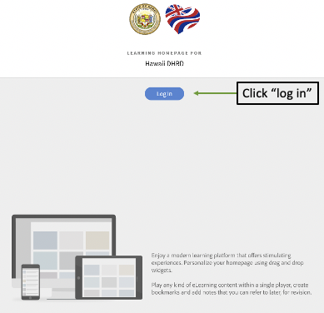
- Sign in screen appears
- Key in your work email address
- Click Continue
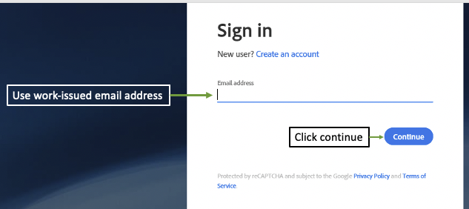

- Select an account Screen appears
- Click on Company or School Account
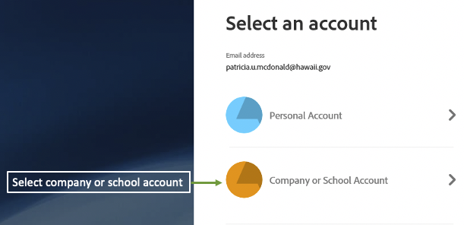

- Password Entry: You may be prompted to key in your password,
Enter the password you used on your initial sign on to your computer system
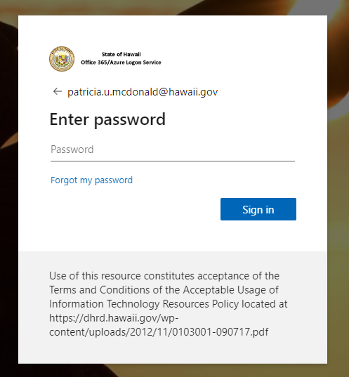

Learner Dashboard
Example of an individual Learner’s Dashboard:
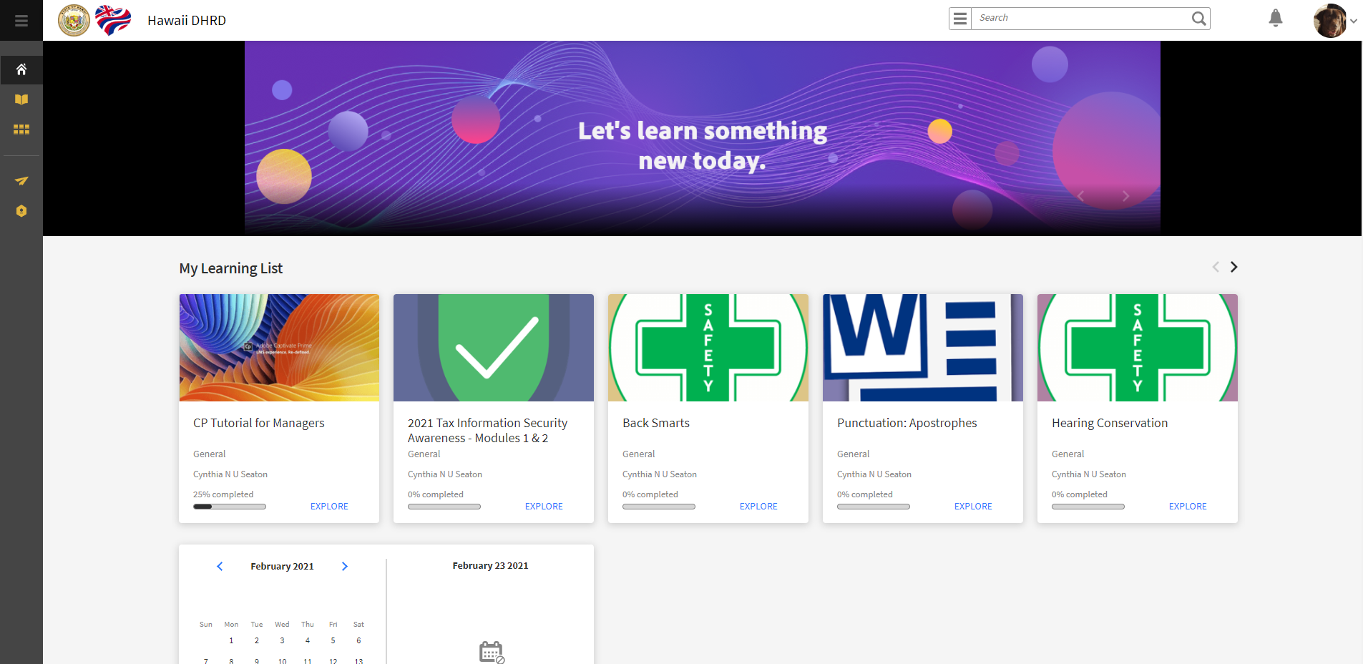

Learnings that have been assigned to you appear in the row titled MY LEARNING LIST. Each course you are required to take has its own tile:
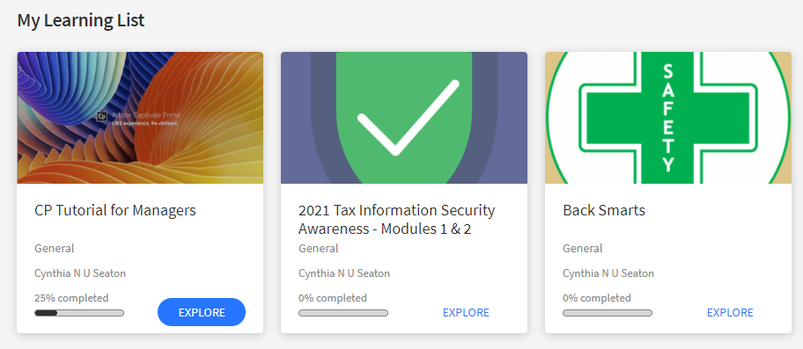

To learn more about the course/s required, click on EXPLORE.

Most of the courses required are “self-paced,” meaning they are “on-demand.” These will automatically launch by clicking the START button when you’re ready to take a course.

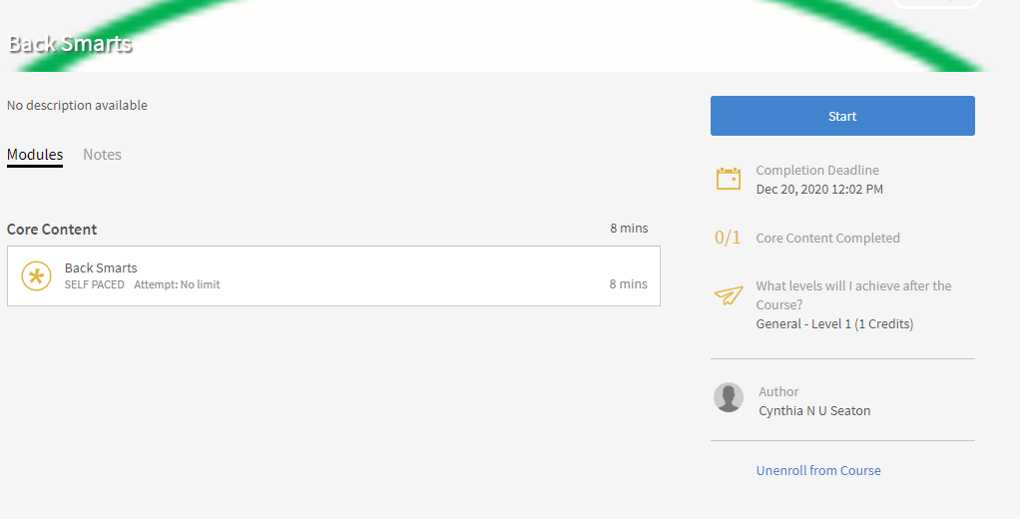

To learn more about your dashboard or some of the other features available in the LMS, please access the OPEN CATALOG and search for “learners.” A number of self-paced trainings are available there. Your departmental Human Resources staff can also help you.
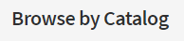
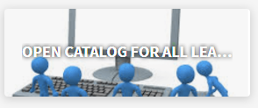
Type in “learner” in search bar to see available courses:
