Adobe Connect Log-In Procedures:
For temporary or exempt employees with an appointment <1 year

To ESTABLISH your Adobe Connect account:

- Contact your HR office for your Employee ID #. You will be using the LAST 6-DIGITS ONLY for LMS access.
- After getting your Employee ID#, email the DHRD Training office at dhrd.training @hawaii.gov.
Please include:
  - First name/Last name
  - Last (6) digits of your employee number
  - Work issued email address
- You will receive a reply from the DHRD Training Office with a temporary password.
- To establish your permanent password, open an Internet browser (Internet Explorer, Google, etc.).

- Type hidhrd.adobeconnect.com on the address line
The ADOBE CONNECT screen will display:
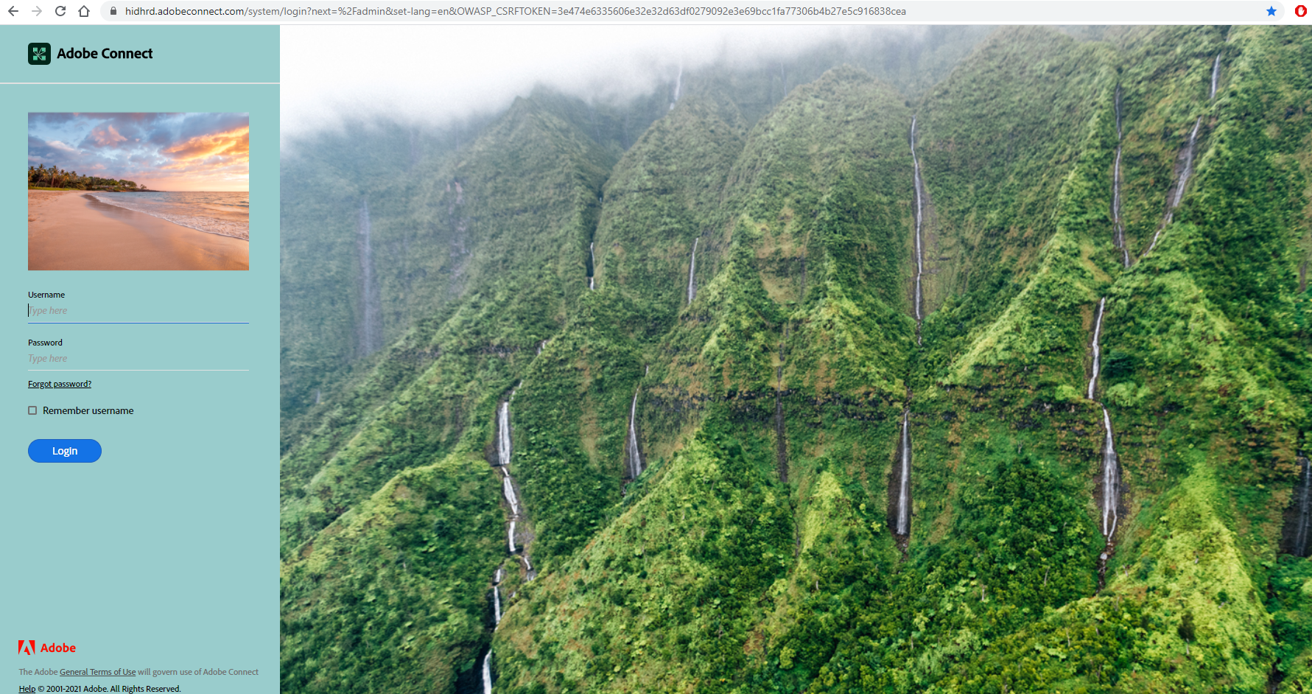

- Type the last 6-digits of your Self-service ID/HiPayroll employee ID number
- Type password in the Password: field (all lowercase)

- Click on Login box to access system
The ADOBE CONNECT Password Screen will display

- Type password in the Old Password field

- Type your new password (create your own: 4 - 32 characters) in the New Password Field

- Retype your new password in Confirm Password field
(Write down your password & Login, last 6-digits Self-service ID/ HIPayroll Employee ID Number, for reference if necessary)

- The ADOBE CONNECT Home page will display.

- Click on Logout in the upper right corner before your name.

Steps 1 - 10 should be done once to establish the employee’s account.
Thereafter, the employee only needs to follow Step 11 to access the On-demand Learning Library.

ACCESS the On-demand Courses

- Go to the DHRD website (dhrd.hawaii.gov)
Click on STATE EMPLOYEES (bottom of screen)
Click on Learning and Development
Click on ADOBE CONNECT ON-DEMAND COURSES FOR TEMPORARY AND CERTAIN EXEMPT EMPLOYEES

ALWAYS LOGIN with the last 6-digits of your HIPayroll employee ID number (eg. 012345) and self-created password to access any of the courses in the Adobe Connect On-demand Learning Library.

