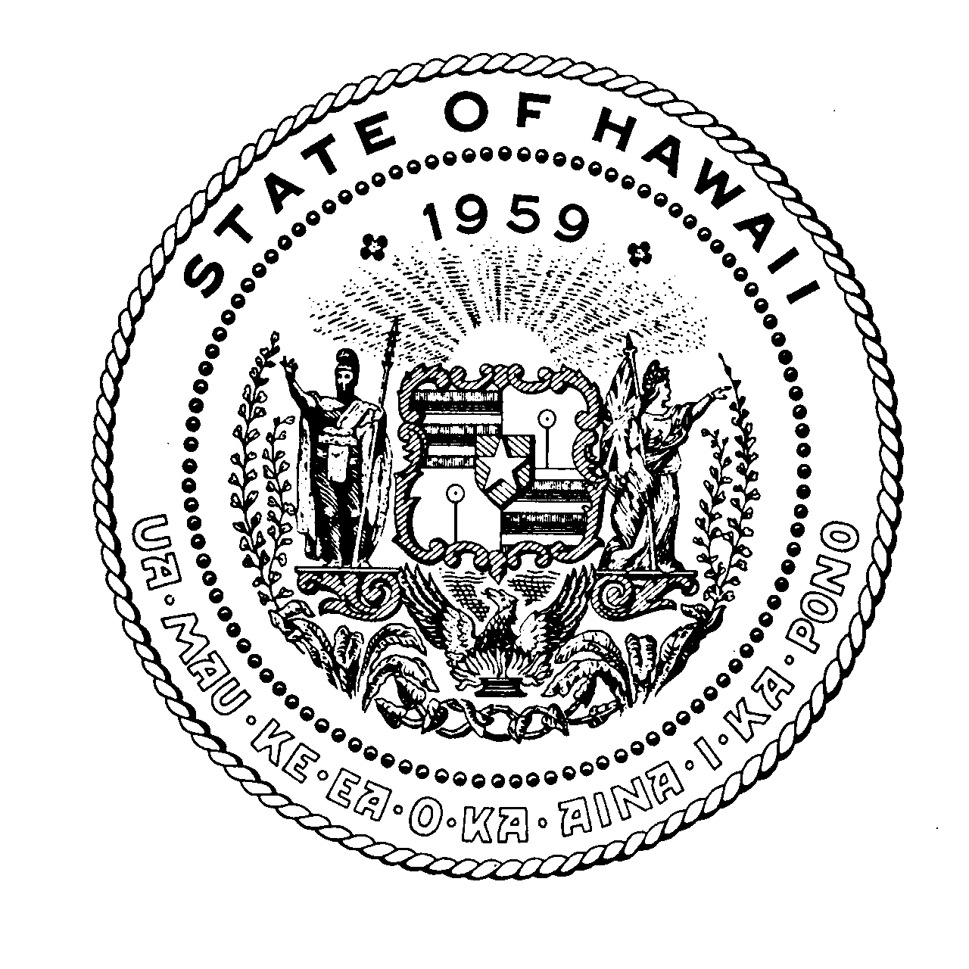
State of Hawaii
Premium Conversion Plan (PCP)
Open Enrollment Period
April 1 – 30, 2021

What is the PCP?
PCP is a voluntary benefit program that allows you to deduct your health plan premiums on a pre-tax basis. This means you’ll be paying less Federal income, state income, and FICA taxes. For more information, please review the PCP Plan Document. *

Who Can Enroll and When Will This Take Effect?
Employees who are enrolled in the Employer-Union Health Benefits Trust Fund (EUTF), and whose health plan premiums are processed through the Department of Accounting & General Services are eligible to enroll in PCP. Your election will become effective on July 1, 2021.

How Can I Enroll or Make Changes?
If you wish to enroll, change or cancel your existing enrollment, complete the PCP section on the EUTF’s EC-1 or EC-1H (for HSTA VB members only) enrollment form and submit it to your Human Resources Office (HRO) designee or the Department of Education- Employee Benefits Unit (DOE-EBU) no later than April 30, 2021.

If you’re already enrolled and do not wish to make any changes, no action needs to be taken, as your enrollment will automatically continue.

Reasons Why You May Wish to Change or Cancel Your PCP Enrollment.
- You no longer have any eligible dependents.
- You are no longer in a domestic or civil union partnership.
- You were not allowed to make a PCP change during the plan year.
If any of the above applies, you should change/cancel your PCP enrollment now. Otherwise, you will not be able to change/cancel your deductions until July 1, 2022, unless an allowable IRS-qualifying change in status occurs (e.g., marriage, birth of child, etc.).

*For more information or to request for a copy of the PCP Plan Document contact your Human Resources Office, DOE-EBU or visit: http://dhrd.hawaii.gov

NOTE: You may want to consult with a tax advisor to help determine whether this Program will benefit you.

Administered by the Department of Human Resources Development
January 2021

